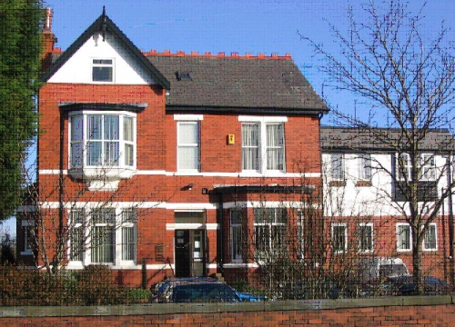

Dr. S.D. Tobin Telephone: 01704 226973

Dr. A. Al-Dahiri

Dr. A. Zubairu

Dr. D Byrne

Dr. S Fu

**NORWOOD SURGERY**

11 Norwood Avenue, Southport PR9 7EG

Dear Patient,

**NORWOOD SURGERY FLU CLINIC – MONDAY 6TH OCTOBER 2025**

**LEYLAND ROAD METHODIST CHURCH, LEYLAND ROAD, SOUTHPORT, PR9 9JQ**

The annual flu vaccination campaign will start in October 2025. Please see details below regarding when to attend for your flu vaccination.

Flu vaccination provides the best protection against unpredictable virus which infects many people and can cause serious illness and death each year. To receive your flu vaccination please attend **Leyland Road Church, Leyland Road, Southport PR9 9JQ** preferably within your allotted time slot dependant on your surname.

Please see table below:

|  |  |
| --- | --- |
| **Time** | **Date** |
|  | **Monday 6th October 2025** |
| **9.30am - 10.30am** | **A, B, C, D** |
| **10.30am-11.30am** | **E, F, G, H** |
| **11.30am-12.30 noon** | **I, J, K,** |
| **12.30 noon-1.30pm** | **L, M, N** |
| **1.30pm-2.30pm** | **CLOSED** |
| **2.30pm-3.30pm** | **O, P, Q, R** |
| **3.30pm-4.30pm** | **S, T, U, V** |
| **4.30pm-5.30pm** | **W, X, Y** |

This is the preferred route to receive your flu vaccination. If you are unable to attend this day, please phone the surgery to book into one of our catch-up clinics. All flu vaccinations must be given by the end of November 2025.

If there is someone you rely on to care for you, please ask them to contact their own GP practice to ask for their free flu vaccination. For more information about the flu vaccine and who is eligible please visit: <https://www.nhs.uk/conditions/vaccinations/who-should-have-flu-vaccine/>

Please note that we are unable to offer COVID vaccinations. If you are eligible, you will be contacted by the National Booking Service who will provide information on how to book your appointment.

Norwood Surgery

**If you would like this letter or information in an alternative format, for example large print or email, if you need help with communicating with us, for example, please let us know. You can call us on 01704 226973.**